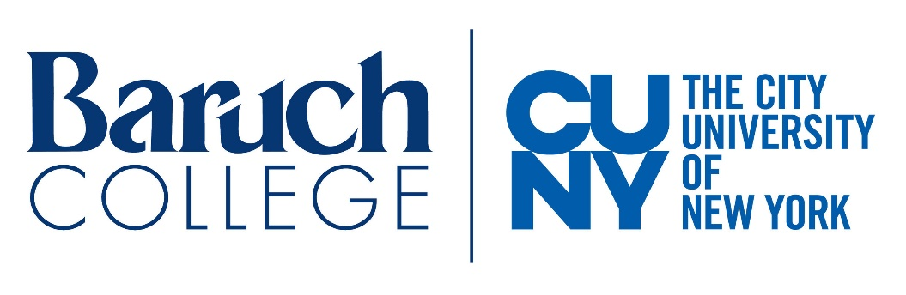


BARUCH COLLEGE
CLIMATE SCHOLARS PROGRAM
May 10, 2021 to March 30, 2022

Overview of Program

Baruch College, City University of New York is recruiting twelve (12) Baruch undergraduates who will be of at least junior status for the fall 2021 semester for participation in the second cohort of the BARUCH CLIMATE SCHOLARS (BCS) PROGRAM funded by the CUNY Office of Continuing Education and Workforce Development. The BARUCH CLIMATE SCHOLARS will work with faculty from the Weissman School of Arts and Sciences, Zicklin School of Business, and Marxe School of International and Public Affairs to explore climate issues in natural sciences, psychology, business, economics, public policy, migration, and communication.

Through interdisciplinary education, research, internships, and teaching experiences the CLIMATE SCHOLARS will develop highly marketable research and communication skills, cultivate sound decision-making skills, share their learning with others, and prepare for careers in innovative climate change mitigation and resilience.

The Climate Scholars program will run from May 10, 2021 to March 30, 2022. Each Climate Scholar will earn a stipend or course credit for participation. All CLIMATE SCHOLARS will present their research at the Baruch Creative Inquiry Day in May 2022.
CLIMATE SCHOLARS will: 1) participate in weekly climate-focused faculty-led seminars, 2) attend Weissman Climate Action lectures, 3) engage in cross-disciplinary climate research in Baruch labs, 4) participate in a two-month NGO or corporate climate change internship, 5) present their research at Baruch Creative Inquiry Day, and 6) share climate change issues as a team of Scholars in large presentations and in small group settings with middle and high school students in the Baruch STEP (Science and Technology Entry Program) Academy, and with Baruch First Year Seminar students.
Application Deadline: Friday, April 16, 2021, 5pm

Program Structure and Requirements:

Weekly Seminar/Didactic Sessions:
- The seminars will be held on Mondays and Wednesdays 10:30AM-12PM – only students who can attend these will be included in the program
- Weekly seminars focus on Climate Change topics led by Baruch Climate Faculty and guest speakers
- Weekly seminars include discussions regarding Scholar progress in research and internship experiences, and the development of presentation plans for STEP Academy and First Year Seminars

Research:
- CLIMATE SCHOLARS work with a faculty mentor and their research teams on existing research projects to develop knowledge and skills in all phases of that lab’s research program
- CLIMATE SCHOLARS will participate in at least 6 hours of faculty-led research per week including lab meetings for at least three months within one of our designated climate research labs
- CLIMATE SCHOLARS will present their research ideas or findings at the annual Baruch Creative Inquiry Day and potentially at regional or national conferences

Internships:
- CLIMATE SCHOLARS will be matched with internship opportunities and will participate in supporting the mission, goals and tasks of the chosen organization
- CLIMATE SCHOLARS will engage in the internship for 10 hours per week for at least two months

Teaching:
- CLIMATE SCHOLARS will work together to prepare materials to educate middle school, high school and First Year Baruch students about climate change including science, impacts, solutions and careers
- CLIMATE SCHOLARS will lead discussions with STEP students and with Baruch First Year Students focused on climate change mitigation, adaptation, resilience and careers

Eligibility Requirements

Students must be Baruch undergraduates with at least a junior standing for the fall 2021 semester, and at least a B average in their undergraduate courses. All students who meet these initial requirements are encouraged to apply. Preference will be given to underrepresented minorities and those who are eager to learn about climate change and to make a difference in Climate Change innovation. Each applicant must be able to commit at least 10 hours each week to involvement in the CLIMATE SCHOLARS program for the full duration of the program. Students must be available on Mondays and Wednesdays 10:30AM-12PM for didactic sessions. A stipend or internship course credit are offered to Scholars. Those who are not US citizens can receive internship course credit only.

Application Process: Please complete the application form below. Attach a short narrative (2 pages or less) describing how participation in the CLIMATE SCHOLARS program will help to facilitate your career goals. Send the application form, narrative and one (unofficial or official) copy of your undergraduate transcript to:
Baruch.ClimateScholars@baruch.cuny.edu by Friday, April 16, 2021, 5pm.
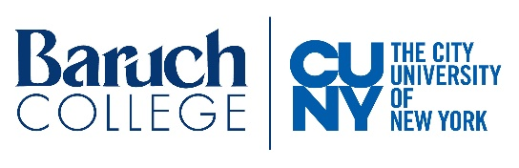


APPLICATION
BARUCH COLLEGE CLIMATE SCHOLARS PROGRAM
May 10, 2021 to March 30, 2022

Please send completed applications to: Baruch.ClimateScholars@baruch.cuny.edu by Friday, April 16, 2021 at 5pm.

Contact Information

Name _______________________________________________________________________________________

Email address: ________________________________________________________________________________

Telephone number: ____________________________________________________________________________

Home Address:________________________________________________________________________________

____________________________________________________________________________________________

Education

Anticipated graduation date____________________Major______________________Minor_______________

GPA- Overall _________________GPA-Major___________________________

What climate change-related courses have you completed/or are planning to take?__________________________
______________________________________________________________________________________________

Career goals____________________________________________________________________________________

Please rank order your preferences for research labs ("1" indicates first choice, "2" indicates second choice, etc.)
______Climate and childbearing decisions
______Social influences involved in climate mitigation and resilience
______Marine eco-systems in the New York Harbor
______The role of business in climate change mitigation and adaptation
______Measuring and predicting climate-caused population migration

Demographics

Age ________ Gender (circle one) Female Male Other

With which racial/ethnic group do you most identify?

___American Indian or Eskimo ___Black (not Hispanic)
___Asian ___White (not Hispanic)
___Hispanic/Latino ___Other (please describe)

Are you a first-generation college student? Yes____ No____

What is your family income?___________

Are you available to attend mandatory meetings on Mondays and Wednesdays 10:30AM-12PM? Yes____ No____

Will you be an enrolled Baruch student for both the Fall 2021 and Spring 2022 terms? Yes____ No____

Are you able to complete a full 10 months as a CLIMATE SCHOLAR? Yes____ No____

Are you able to spend 10-12 hours a week in CLIMATE SCHOLAR PROGRAM activities? Yes____ No____

A stipend or internship course credit will be offered to Scholars. Those who are not US citizens can receive internship course credit only. Please indicate how you would prefer to be compensated for participation (please check only one):

Monetary Stipend Only________

Internship Course Credit (one (1) credit fall 2021 and one (1) credit spring 2022) _______

Either Monetary Stipend or Internship Course Credit _______

How did you hear about this program? ______________________________________________

Attach a short narrative (2 pages or less) describing your interest in climate change, past experience promoting climate change mitigation, adaptation or resilience, your long-term career aspirations and how participation in the BARUCH CLIMATE SCHOLAR PROGRAM will help you achieve your goals.

Include one (unofficial or official) copy of your undergraduate transcript with the application.

All applications must be submitted to: Baruch.ClimateScholars@baruch.cuny.edu by Friday, April 16, 2021 at 5pm.

